**Stream Assignment**

**Aditya Yadav**

**Q1)** Create the following classes:

class Fruit { String name; int calories; int price; String color; }

**Display the following:**

**1. Display the fruit names of low calories fruits i.e. calories < 100 sorted in descending order of calories.**

**2. Display color wise list of fruit names.**

**3. Display only RED color fruits sorted as per their price in ascending order.**

**Code Specifications:**

**c**lass Fruit {  
    private String name;  
    private int calories;  
    private int price;  
    private String color;  
}  
  
public class Assignment5Q1 {

    public static List<String> reverseSort(ArrayList<Fruit> fruits) {}  
    public static ArrayList<Fruits> sort(ArrayList<Fruits> Fruits) {}

    public static ArrayList<Fruit> filterRedSortPrice(ArrayList<Fruit>

    public static void main(String[] args) {}

}

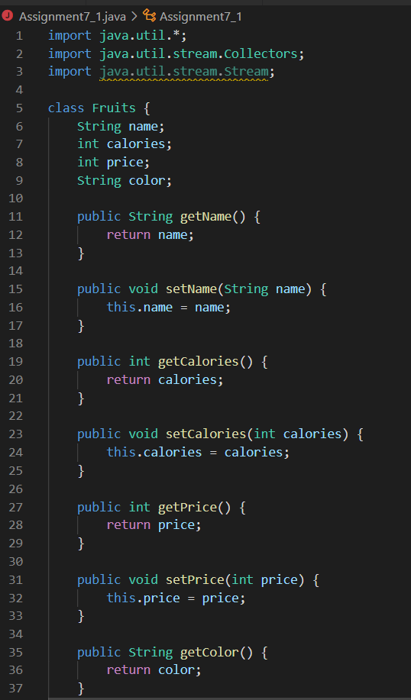

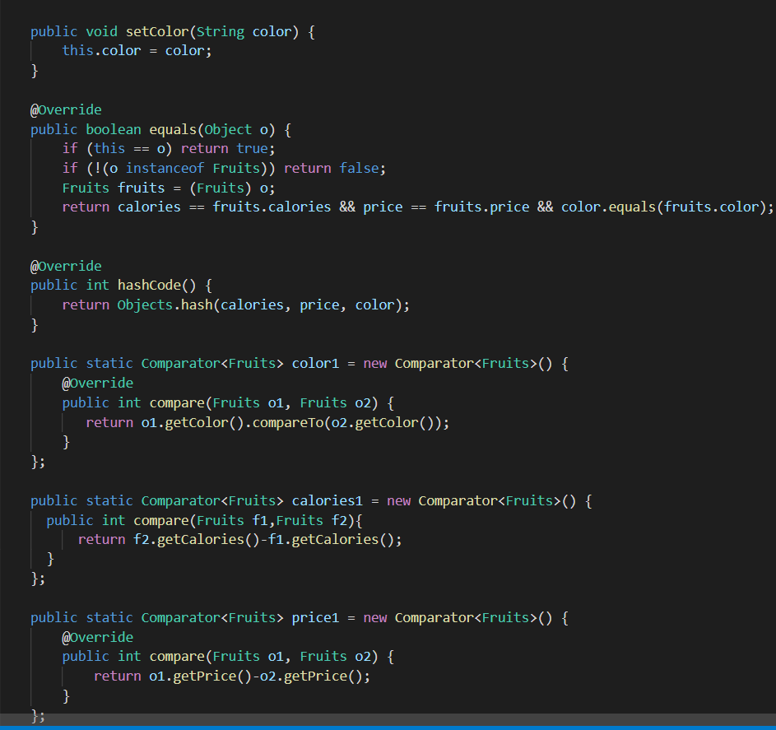

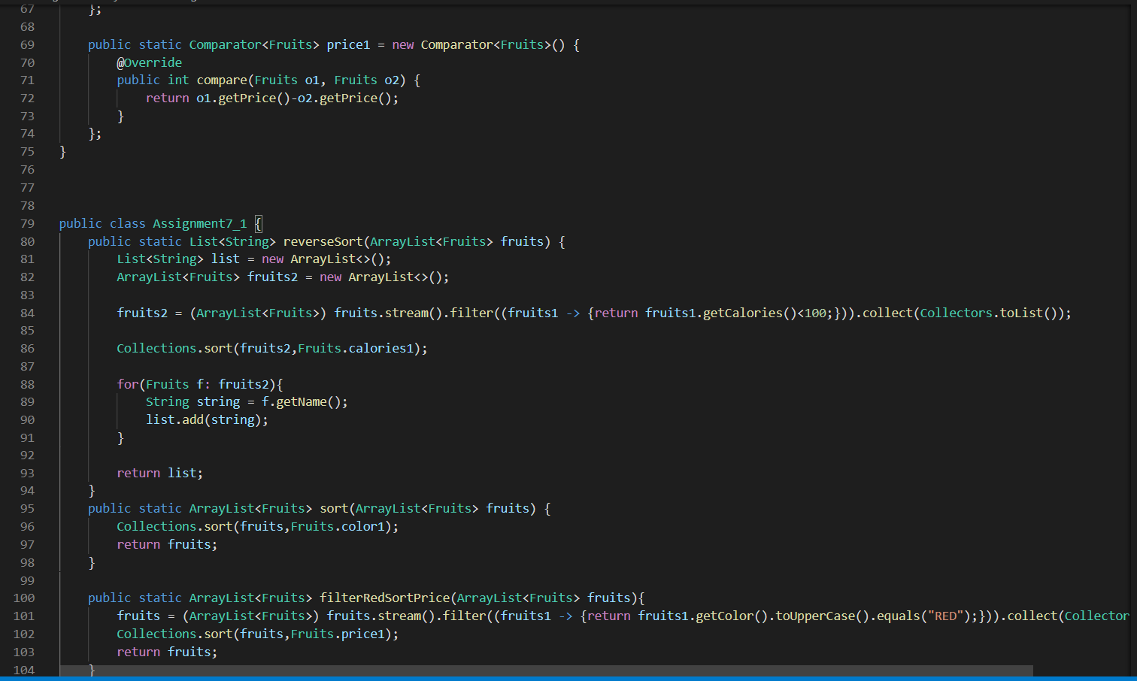

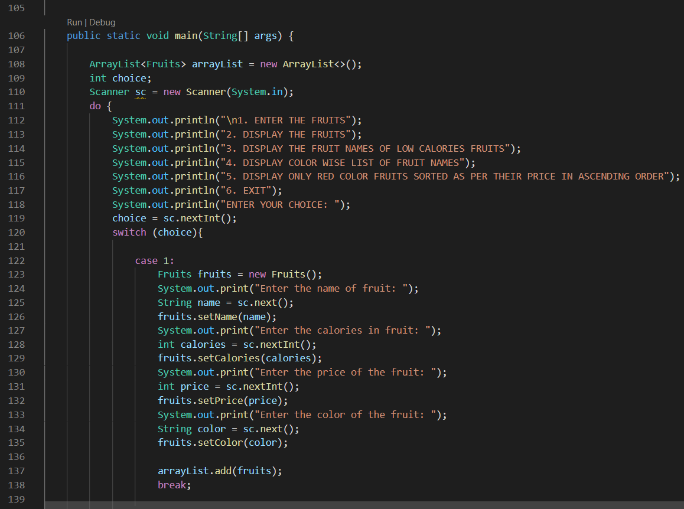

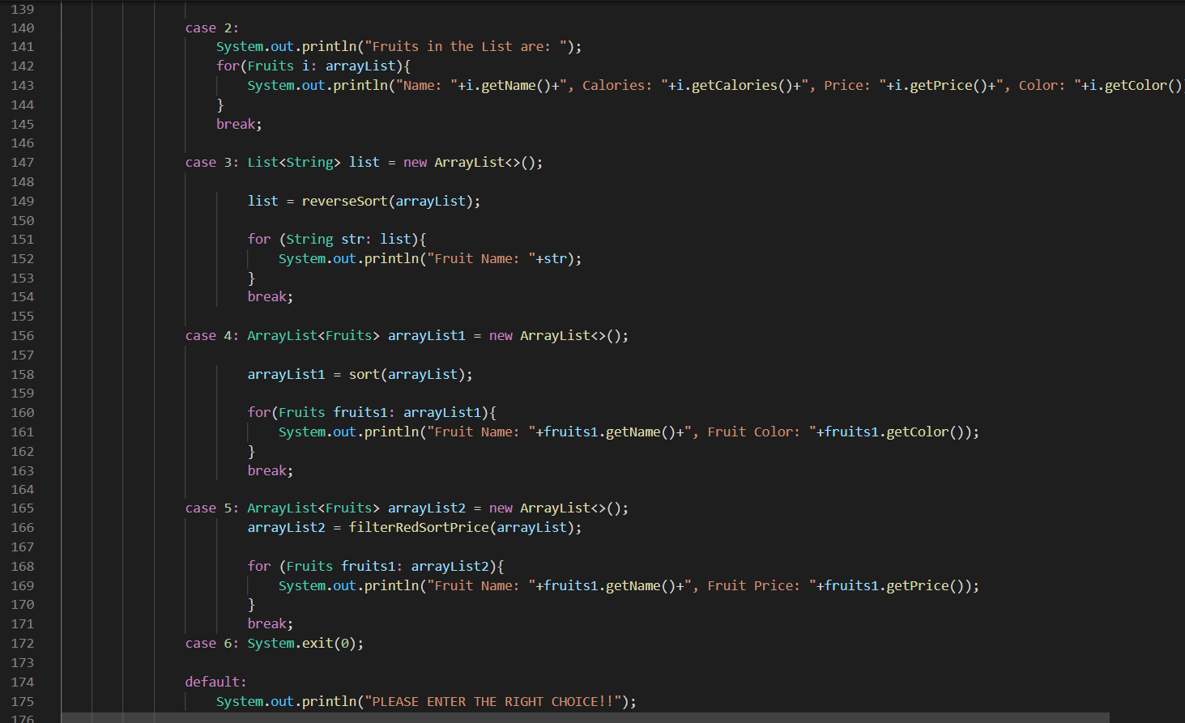

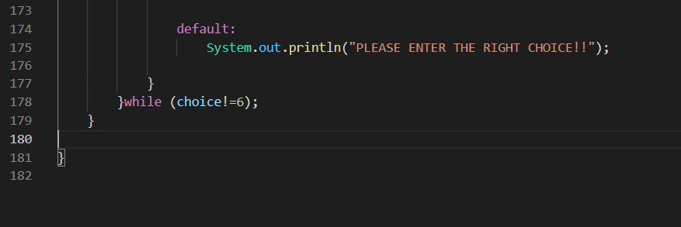

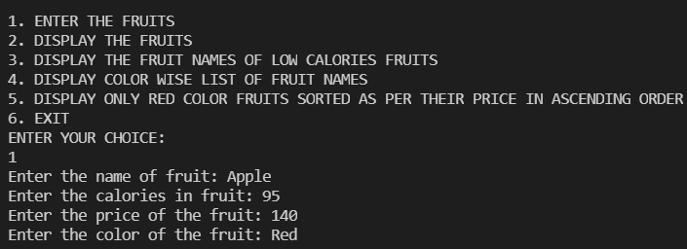

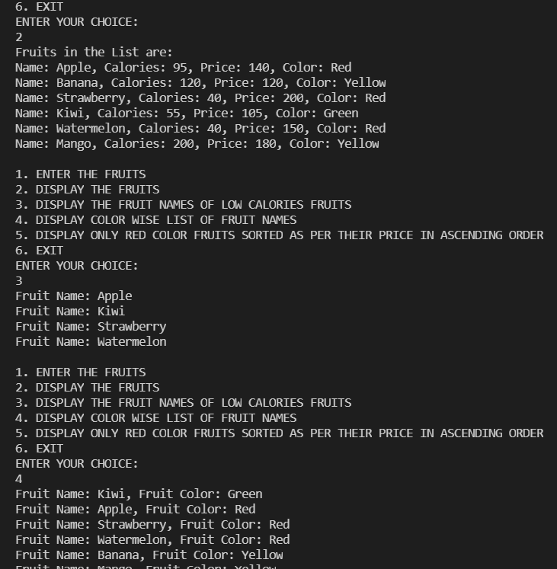

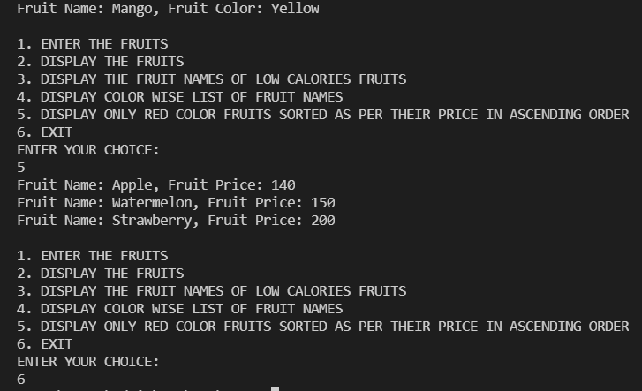

**Q2)** Setup:

Create the following classes:

class News { int newsId; String postedByUser; String commentByUser; String comment; }

**Find Out:**

**1. Find out the newsId which has received maximum comments.**

**2. Find out how many times the word 'budget' arrived in user comments all news.**

**3. Find out which user has posted maximum comments.**

**4. Display commentByUser wise number of comments.**

**Code Specifications:**

class News {  
    private int newsId;  
    private String postedByUser;  
    private String commentByUser;  
    private String comment;  
}  
  
public class Assignment5Q2 {  
    public static int maxComments(List<News> news) {}

    public static int budgetCount (List < News > news) {}  
    public static String maxCommentsByUser (List < News > news) {}

    public static Map<String, Integer> sortMaxCommentsByUser (List < News > news) {}

    public static void main(String[] args) {}  
}

Code:

import java.util.*;

import java.util.stream.Collectors;

class News {

    int newsId;

    String postedByUser;

    String commentByUser;

    String comment;

    public News(int newsId, String postedByUser, String commentByUser, String comment) {

        this.newsId = newsId;

        this.postedByUser = postedByUser;

        this.commentByUser = commentByUser;

        this.comment = comment;

    }

    public News() {

    }

    public int getNewsId() {

        return newsId;

    }

    public void setNewsId(int newsId) {

        this.newsId = newsId;

    }

    public String getPostedByUser() {

        return postedByUser;

    }

    public void setPostedByUser(String postedByUser) {

        this.postedByUser = postedByUser;

    }

    public String getCommentByUser() {

        return commentByUser;

    }

    public void setCommentByUser(String commentByUser) {

        this.commentByUser = commentByUser;

    }

    public String getComment() {

        return comment;

    }

    public void setComment(String comment) {

        this.comment = comment;

    }

    @Override

    public boolean equals(Object o) {

        if (this == o) return true;

        if (!(o instanceof News)) return false;

        News news = (News) o;

        return newsId == news.newsId && commentByUser.equals(news.commentByUser) && comment.equals(news.comment);

    }

    @Override

    public int hashCode() {

        return Objects.hash(newsId, commentByUser, comment);

    }

}

public class Assignment7_2 {

    public static int maxComments(List<News> news) {

        Map<Integer,Integer> map = new HashMap<>();

        for (News news1: news){

            int id = news1.getNewsId();

            if(map.containsKey(id)){

                map.put(id,map.get(id)+1);

            } else {

                map.put(id,1);

            }

        }

        List<Map.Entry<Integer, Integer>> list = new ArrayList<>(map.entrySet());

        list.sort(Map.Entry.comparingByValue());

        return list.get(list.size()-1).getKey();

    }

    public static int budgetCount (List < News > news) {

        int count = 0;

        List<String> list = new ArrayList<>();

        for(News i: news){

            String comment = i.getComment();

            list.add(Arrays.toString(comment.split("budget")));

        }

        return list.size();

    }

    public static String maxCommentsByUser (List < News > news) {

        Map<String,Integer> map = new HashMap<>();

        for(News news1: news){

            String username = news1.getCommentByUser();

            if(map.containsKey(username)){

                map.put(username,map.get(username)+1);

            } else {

                map.put(username,1);

            }

        }

        List<Map.Entry<String, Integer>> list = new ArrayList<>(map.entrySet());

        list.sort(Map.Entry.comparingByValue());

        return list.get(list.size()-1).getKey();

    }

    public static Map<String, Integer> sortMaxCommentsByUser (List < News > news) {

        Map<String,Integer> map = new HashMap<>();

        for(News news1: news){

            String username = news1.getCommentByUser();

            if(map.containsKey(username)){

                map.put(username,map.get(username)+1);

            } else {

                map.put(username,1);

            }

        }

        HashMap<String, Integer> temp

                = map.entrySet()

                .stream()

                .sorted((i1, i2)

                        -> i2.getValue().compareTo(

                        i1.getValue()))

                .collect(Collectors.toMap(

                        Map.Entry::getKey,

                        Map.Entry::getValue,

                        (e1, e2) -> e1, LinkedHashMap::new));

        return temp;

    }

    public static void main(String[] args) {

        List<News> list = new ArrayList<>();

        int choice;

        Scanner sc = new Scanner(System.in);

        News news1 = new News(1,

                "Ayush Agrawal",

                "Atharva Upadhye",

                "I want to see the budget");

        News news2 = new News(1,

                "Ayush Agrawal",

                "Pratik Nandurkar",

                "budget is my fundamental right");

        News news3 = new News(2,

                "Ritik Dixit",

                "Shraddha Gupta",

                "budget 2022");

        list.add(news1);

        list.add(news2);

        list.add(news3);

        do{

            System.out.println("1. ENTER THE NEWS DETAILS");

            System.out.println("2. DISPLAY THE NEWS DETAILS");

            System.out.println("3. FIND OUT THE newsId WHICH HAS RECEIVED MAXIMUM COMMENTS.");

            System.out.println("4. FIND OUT HOW MANY TIMES THE WORD 'BUDGET' ARRIVED IN USER COMMENTS ALL NEWS.");

            System.out.println("5. FIND OUT WHICH USER HAS POSTED MAXIMUM COMMENTS.");

            System.out.println("6. DISPLAY COMMENT BY USER WISE NUMBER OF COMMENTS.");

            System.out.println("7. EXIT");

            System.out.println("ENTER YOUR CHOICE:");

            choice = sc.nextInt();

            switch (choice){

                case 1:

                    News news = new News();

                    try {

                        System.out.print("Enter the newsID: ");

                        int newId = sc.nextInt();

                        news.setNewsId(newId);

                        sc.nextLine();

                        System.out.print("Enter the name who posted the news: ");

                        String name = sc.nextLine();

                        news.setPostedByUser(name);

                        System.out.print("Enter the comment: ");

                        String comment = sc.nextLine();

                        news.setComment(comment);

                        System.out.print("Enter the name who posted the comment: ");

                        String username = sc.nextLine();

                        news.setCommentByUser(username);

                        list.add(news);

                    }catch (Exception e){

                        System.out.println(e);

                        System.out.println("Enter the correct input please!!");

                    }

                    break;

                case 2: for(News new1: list){

                    System.out.println("News ID:         "+new1.getNewsId());

                    System.out.println("News Posted By:  "+new1.getPostedByUser());

                    System.out.println("Comment by User: "+new1.getCommentByUser());

                    System.out.println("Comment Posted:  "+new1.getComment());

                    System.out.println();

                }

                break;

                case 3: int id = maxComments(list);

                    System.out.println("NEWS ID WHICH HAS RECEIVED MAXIMUM COMMENTS: "+id);

                    System.out.println();

                    break;

                case 4: int countBudget = budgetCount(list);

                    System.out.println("HOW MANY TIMES THE WORD 'BUDGET' ARRIVED IN USER COMMENTS ALL NEWS: "+countBudget);

                    System.out.println();

                    break;

                case 5: String name = maxCommentsByUser(list);

                    System.out.println("USER HAS POSTED MAXIMUM COMMENTS: "+name);

                    System.out.println();

                    break;

                case 6: Map<String,Integer> maxCommentByUser = sortMaxCommentsByUser(list);

                for (Map.Entry<String,Integer> mp: maxCommentByUser.entrySet()){

                    System.out.println("Name of the User: "+mp.getKey());

                    System.out.println("Numbers of Comments: "+mp.getValue());

                    System.out.println();

                }

                System.out.println();

                break;

            }

        }while (choice!=7);

    }

}

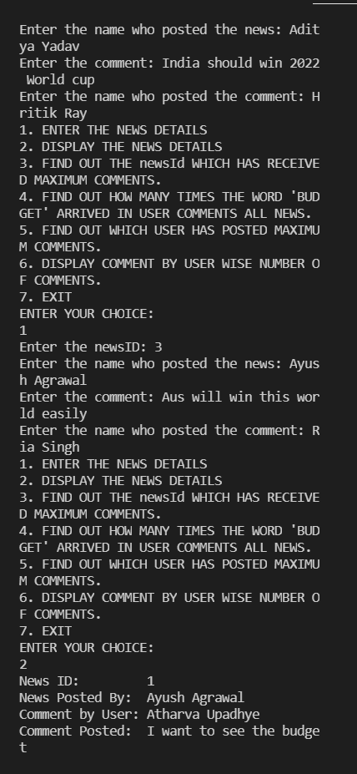

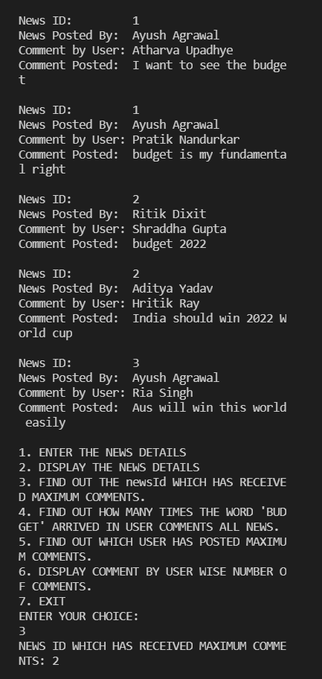

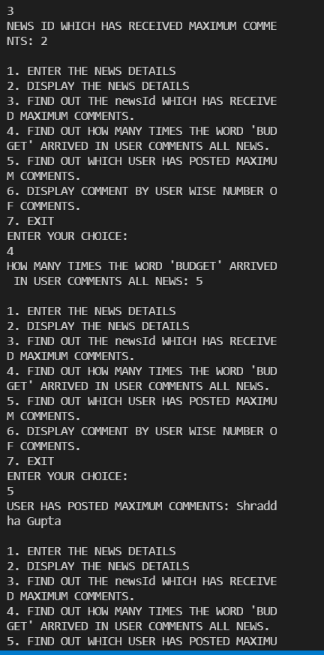

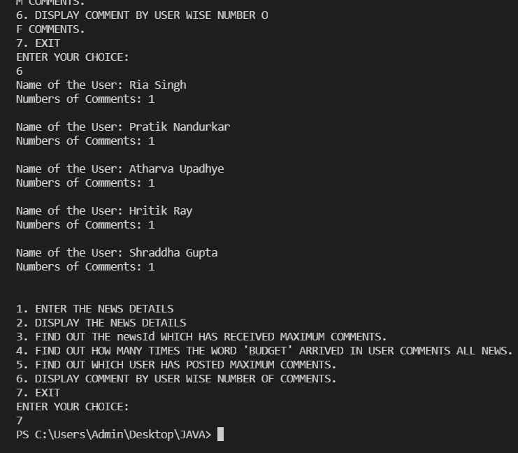

Q3. Setup:

Create the following classes:

class Trader { String name; String city; }

**Find Out:**

**1. What are all the unique cities where the traders work?**

**2. Find all traders from Pune and sort them by name.**

**3. Return a string of all traders’ names sorted alphabetically.**

**4. Are any traders based in Indore?**

**Code Specifications:**

class Trader {  
    private String name;  
    private String city;  
}  
  
public class Assignment5Q9 {  
    public static List<String> printUniqueCities (List <Trader> traders) {  }

    public static List<String> tradersFromPuneSortByName(List<Trader> traders) {}  
    public static String allTrader3Names(List<Trader> traders) {}  
    public static ArrayList<Trader> areAnyTradersFromIndore(ArrayList<Trader> traders) {}

    public static void main(String[] args) {}  
}

Code:

import java.util.*;

class Trader {

    String name;

    String city;

    public Trader(String name, String city) {

        this.name = name;

        this.city = city;

    }

    public Trader(){

    }

    public String getName() {

        return name;

    }

    public void setName(String name) {

        this.name = name;

    }

    public String getCity() {

        return city;

    }

    public void setCity(String city) {

        this.city = city;

    }

    @Override

    public boolean equals(Object o) {

        if (this == o) return true;

        if (!(o instanceof Trader)) return false;

        Trader trader = (Trader) o;

        return name.equals(trader.name) && city.equals(trader.city);

    }

    @Override

    public int hashCode() {

        return Objects.hash(name, city);

    }

    public static Comparator<Trader> comparator = new Comparator<Trader>() {

        @Override

        public int compare(Trader o1, Trader o2) {

            return o1.getName().compareTo(o2.getName());

        }

    };

}

public class Assignment7_3 {

    public static List<String> printUniqueCities (List <Trader> traders) {

        Map<String,String> map = new HashMap<>();

        List<String> cities = new ArrayList<>();

        for (Trader trader: traders){

            map.putIfAbsent(trader.getCity(),trader.getName());

        }

        for (Map.Entry<String,String> mp: map.entrySet()){

            cities.add(mp.getKey());

        }

        return cities;

    }

    public static List<String> tradersFromPuneSortByName(List<Trader> traders) {

        List<String> tradersFromPune = new ArrayList<>();

        for (Trader trader: traders){

            if(trader.getCity().toUpperCase().equals("PUNE")){

                tradersFromPune.add(trader.getName());

            }

        }

        Collections.sort(tradersFromPune);

        return tradersFromPune;

    }

    public static List<Trader> allTrader3Names(List<Trader> traders) {

       traders.sort(Trader.comparator);

        return traders;

    }

    public static ArrayList<Trader> areAnyTradersFromIndore(ArrayList<Trader> traders) {

        ArrayList<Trader> traderList = new ArrayList<>();

        for(Trader trader: traders){

            if(trader.getCity().toUpperCase().equals("INDORE")){

                traderList.add(trader);

            }

        }

        return traderList;

    }

    public static void main(String[] args) {

        Scanner sc = new Scanner(System.in);

        ArrayList<Trader> arrayList = new ArrayList<>();

        Trader trader1 = new Trader("Ayush Agrawal","Pune");

        Trader trader2 = new Trader("Hrithik Ray","Bangalore");

        Trader trader3 = new Trader("Aditya Yadav","Pune");

        Trader trader4 = new Trader("Ria Singh","Pune");

        Trader trader5 = new Trader("Pratik Kamdi","Indore");

        Trader trader6 = new Trader("Atharva Telange","Indore");

        arrayList.add(trader1);

        arrayList.add(trader2);

        arrayList.add(trader3);

        arrayList.add(trader4);

        arrayList.add(trader5);

        arrayList.add(trader6);

        int choice;

        do{

            System.out.println("\n1. ENTER THE TRADERS DETAILS");

            System.out.println("2. DISPLAY THE TRADERS DETAILS");

            System.out.println("3. DISPLAY ALL UNIQUE CITIES WHERE TRADERS WORK");

            System.out.println("4. DISPLAY ALL TRADERS FROM PUNE SORTED BY NAME");

            System.out.println("5. DISPLAY ALL TRADERS NAMES SORTED ALPHABETICALLY");

            System.out.println("6. DISPLAY ALL TRADERS FROM INDORE");

            System.out.println("7. EXIT");

            System.out.println("ENTER YOUR CHOICE");

            choice = sc.nextInt();

            switch (choice){

                case 1:

                    Trader trader = new Trader();

                    sc.nextLine();

                    System.out.println("Enter the Trader Name: ");

                    String name = sc.nextLine();

                    trader.setName(name);

                    System.out.println("Enter the City Name: ");

                    String city = sc.nextLine();

                    trader.setCity(city);

                    arrayList.add(trader);

                    break;

                case 2:

                    System.out.println("List of traders: ");

                    for (Trader trade: arrayList){

                        System.out.println("Trader Name: "+trade.getName());

                        System.out.println("Trader City: "+trade.getCity());

                    }

                    System.out.println();

                    break;

                case 3:

                    List<String> list = new ArrayList<>();

                    list = printUniqueCities(arrayList);

                    System.out.println("All uniques cities where traders work: ");

                    for (String str: list){

                        System.out.println(str);

                    }

                    System.out.println();

                    break;

                case 4:

                    List<String> list1 = new ArrayList<>();

                    list1 = tradersFromPuneSortByName(arrayList);

                    System.out.println("All traders from Pune: ");

                    for (String str: list1){

                        System.out.println(str);

                    }

                    System.out.println();

                    break;

                case 5: List<Trader> arraylist2 = new ArrayList<>();

                arraylist2 = allTrader3Names(arrayList);

                    System.out.println("All Traders Name:");

                    for(Trader trader7: arraylist2){

                        System.out.println("Name: "+trader7.getName());

                        System.out.println("City: "+trader7.getCity());

                        System.out.println();

                    }

                    System.out.println();

                    break;

                case 6: List<Trader> traderList = new ArrayList<>();

                    traderList = areAnyTradersFromIndore(arrayList);

                    System.out.println("All traders from Indore: ");

                    for(Trader trader7: traderList){

                        System.out.println("Name: "+trader7.getName());

                    }

                    System.out.println();

                    break;

                case 7: System.exit(0);

                default:

                    System.out.println("PLEASE ENTER THE RIGHT CHOICE!");

            }

        }while (choice!=7);

    }

}

